UNITED STATES
SECURITIES AND EXCHANGE COMMISSION
Washington, D.C. 20549
FORM 8-K
CURRENT REPORT
Pursuant to Section 13 or 15(d) of the Securities Exchange Act of 1934
Date of Report (Date of earliest event reported): August 3, 2026
Arbor Realty Trust, Inc.
(Exact name of registrant as specified in its charter)

Maryland |  |  | 001-32136 |  |  | 20-0057959
(State or other jurisdiction of incorporation) |  |  | (Commission File Number) |  |  | (IRS Employer Identification No.)
333 Earle Ovington Boulevard, Suite 900 Uniondale, New York |  |  |  |  |  | 11553
(Address of principal executive offices) |  |  |  |  |  | (Zip Code)
Registrant’s telephone number, including area code: (516) 506-4200
Check the appropriate box below if the Form 8-K filing is intended to simultaneously satisfy the filing obligation of the registrant under any of the following provisions:
o |  |  | Written communications pursuant to Rule 425 under the Securities Act (17 CFR 230.425)
o |  |  | Soliciting material pursuant to Rule 14a-12 under the Exchange Act (17 CFR 240.14a-12)
o |  |  | Pre-commencement communications pursuant to Rule 14d-2(b) under the Exchange Act (17 CFR 240.14d-2(b))
o |  |  | Pre-commencement communications pursuant to Rule 13e-4(c) under the Exchange Act (17 CFR 240.13e-4(c))
Securities registered pursuant to Section 12(b) of the Act:
Title of each class |  |  |  |  |  | Trading symbols |  |  |  |  |  | Name of each exchange on which registered
Common Stock, par value $0.01 per share |  |  |  |  |  | ABR |  |  |  |  |  | New York Stock Exchange
Preferred Stock, 6.375% Series D Cumulative Redeemable, par value $0.01 per share |  |  |  |  |  | ABR-PD |  |  |  |  |  | New York Stock Exchange
Preferred Stock, 6.25% Series E Cumulative Redeemable, par value $0.01 per share |  |  |  |  |  | ABR-PE |  |  |  |  |  | New York Stock Exchange
Preferred Stock, 6.25% Series F Fixed-to-Floating Rate Cumulative Redeemable, par value $0.01 per share |  |  |  |  |  | ABR-PF |  |  |  |  |  | New York Stock Exchange

Indicate by check mark whether the registrant is an emerging growth company as defined in Rule 405 of the Securities Act of 1933 (§230.405 of this chapter) or Rule 12b-2 of the Securities Exchange Act of 1934 (§240.12b-2 of this chapter).
Emerging growth company o
If an emerging growth company, indicate by check mark if the registrant has elected not to use the extended transition period for complying with any new or revised financial accounting standards provided pursuant to Section 13(a) of the Exchange Act. o

Item 7.01 Regulations FD Disclosure.
On August 3, 2026, Arbor Realty Trust, Inc. posted on its website an investor presentation (the “Investor Presentation”). A copy of the Investor Presentation is furnished as Exhibit 99.1 to this Current Report on Form 8-K and is incorporated by reference into this Item 7.01.
The information in this Item 7.01 (including Exhibit 99.1) is being furnished and shall not be deemed “filed” for purposes of Section 18 of the Securities Exchange Act of 1934, as amended (the “Exchange Act”), or otherwise subject to the liabilities of that section, nor shall it be deemed incorporated by reference into any filing under the Securities Act of 1933, as amended, or the Exchange Act, except as shall be expressly set forth by specific reference in such a filing.

Item 9.01 Financial Statements and Exhibits.
(d) Exhibits
Exhibit Number |  |  |  |  |  | Exhibit
99.1 |  |  |  |  |  | Investor Presentation of Arbor Realty Trust, Inc., dated July 2026 (furnished herewith).
104 |  |  |  |  |  | Cover Page Interactive Data File - the cover page XBRL tags are embedded within the Inline XBRL document.

SIGNATURE
Pursuant to the requirements of the Securities Exchange Act of 1934, the registrant has duly caused this report to be signed on its behalf by the undersigned hereunto duly authorized.
 |  |  | ARBOR REALTY TRUST, INC.
 |  |  | By: |  |  | /s/ Paul Elenio
 |  |  | Name: |  |  | Paul Elenio
 |  |  | Title: |  |  | Chief Financial Officer
Date: August 3, 2026
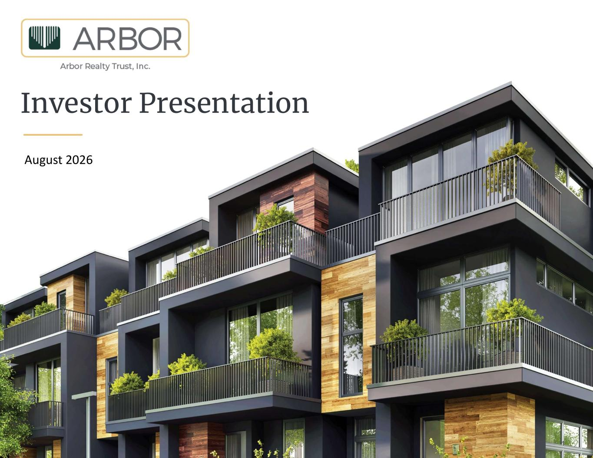

August 2026 Investor Presentation 1

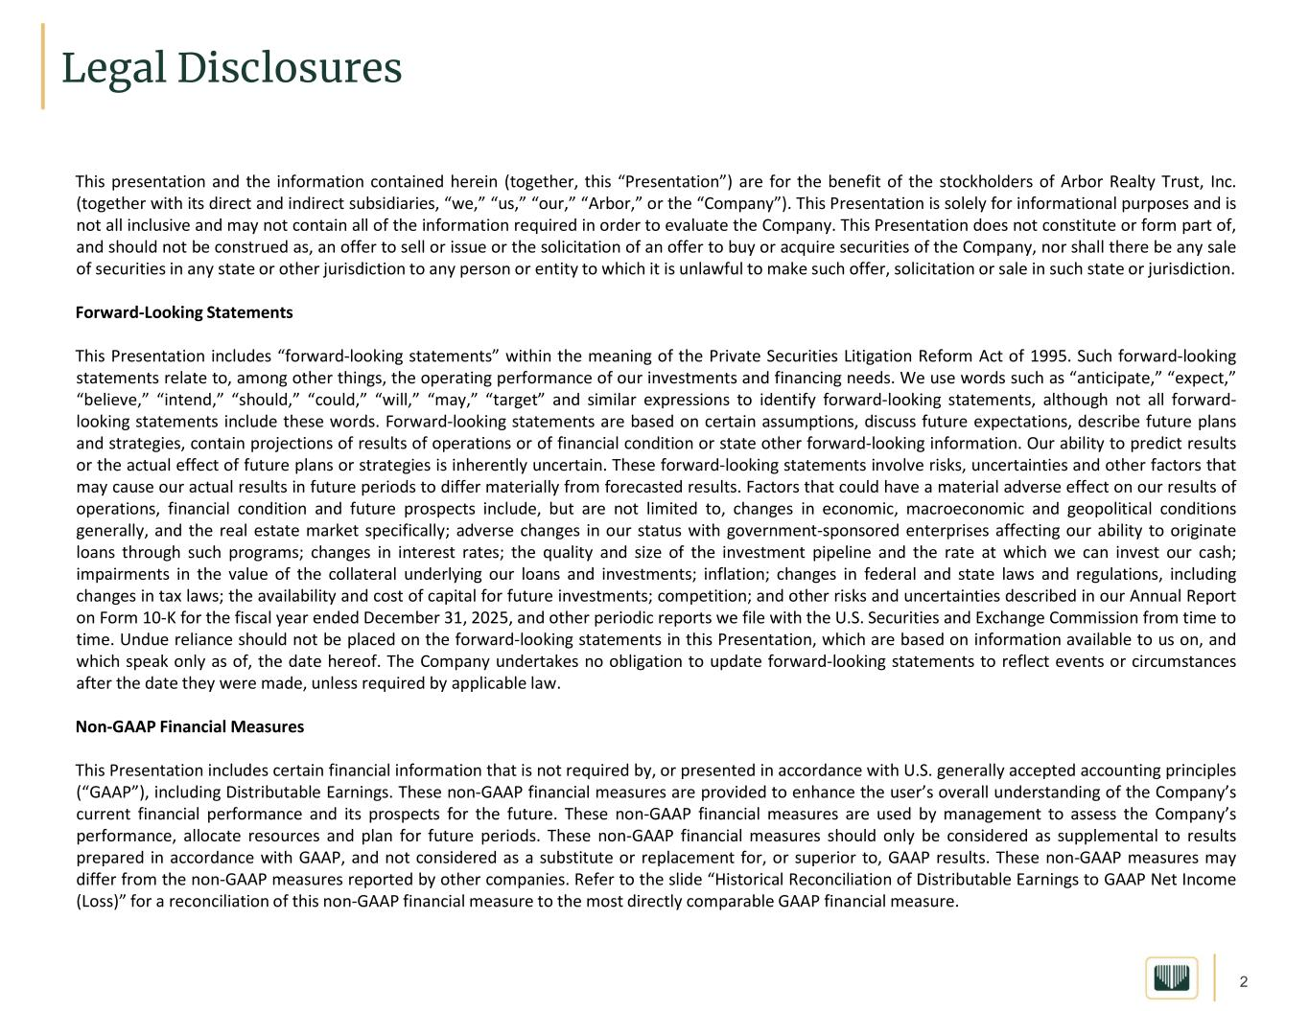
2 Legal Disclosures This presentation and the information contained herein (together, this “Presentation”) are for the benefit of the stockholders of Arbor Realty Trust, Inc. (together with its direct and indirect subsidiaries, “we,” “us,” “our,” “Arbor,” or the “Company”). This Presentation is solely for informational purposes and is not all inclusive and may not contain all of the information required in order to evaluate the Company. This Presentation does not constitute or form part of, and should not be construed as, an offer to sell or issue or the solicitation of an offer to buy or acquire securities of the Company, nor shall there be any sale of securities in any state or other jurisdiction to any person or entity to which it is unlawful to make such offer, solicitation or sale in such state or jurisdiction. Forward-Looking Statements This Presentation includes “forward-looking statements” within the meaning of the Private Securities Litigation Reform Act of 1995. Such forward-looking statements relate to, among other things, the operating performance of our investments and financing needs. We use words such as “anticipate,” “expect,” “believe,” “intend,” “should,” “could,” “will,” “may,” “target” and similar expressions to identify forward-looking statements, although not all forward- looking statements include these words. Forward-looking statements are based on certain assumptions, discuss future expectations, describe future plans and strategies, contain projections of results of operations or of financial condition or state other forward-looking information. Our ability to predict results or the actual effect of future plans or strategies is inherently uncertain. These forward-looking statements involve risks, uncertainties and other factors that may cause our actual results in future periods to differ materially from forecasted results. Factors that could have a material adverse effect on our results of operations, financial condition and future prospects include, but are not limited to, changes in economic, macroeconomic and geopolitical conditions generally, and the real estate market specifically; adverse changes in our status with government-sponsored enterprises affecting our ability to originate loans through such programs; changes in interest rates; the quality and size of the investment pipeline and the rate at which we can invest our cash; impairments in the value of the collateral underlying our loans and investments; inflation; changes in federal and state laws and regulations, including changes in tax laws; the availability and cost of capital for future investments; competition; and other risks and uncertainties described in our Annual Report on Form 10-K for the fiscal year ended December 31, 2025, and other periodic reports we file with the U.S. Securities and Exchange Commission from time to time. Undue reliance should not be placed on the forward-looking statements in this Presentation, which are based on information available to us on, and which speak only as of, the date hereof. The Company undertakes no obligation to update forward-looking statements to reflect events or circumstances after the date they were made, unless required by applicable law. Non-GAAP Financial Measures This Presentation includes certain financial information that is not required by, or presented in accordance with U.S. generally accepted accounting principles (“GAAP”), including Distributable Earnings. These non-GAAP financial measures are provided to enhance the user’s overall understanding of the Company’s current financial performance and its prospects for the future. These non-GAAP financial measures are used by management to assess the Company’s performance, allocate resources and plan for future periods. These non-GAAP financial measures should only be considered as supplemental to results prepared in accordance with GAAP, and not considered as a substitute or replacement for, or superior to, GAAP results. These non-GAAP measures may differ from the non-GAAP measures reported by other companies. Refer to the slide “Historical Reconciliation of Distributable Earnings to GAAP Net Income (Loss)” for a reconciliation of this non-GAAP financial measure to the most directly comparable GAAP financial measure.

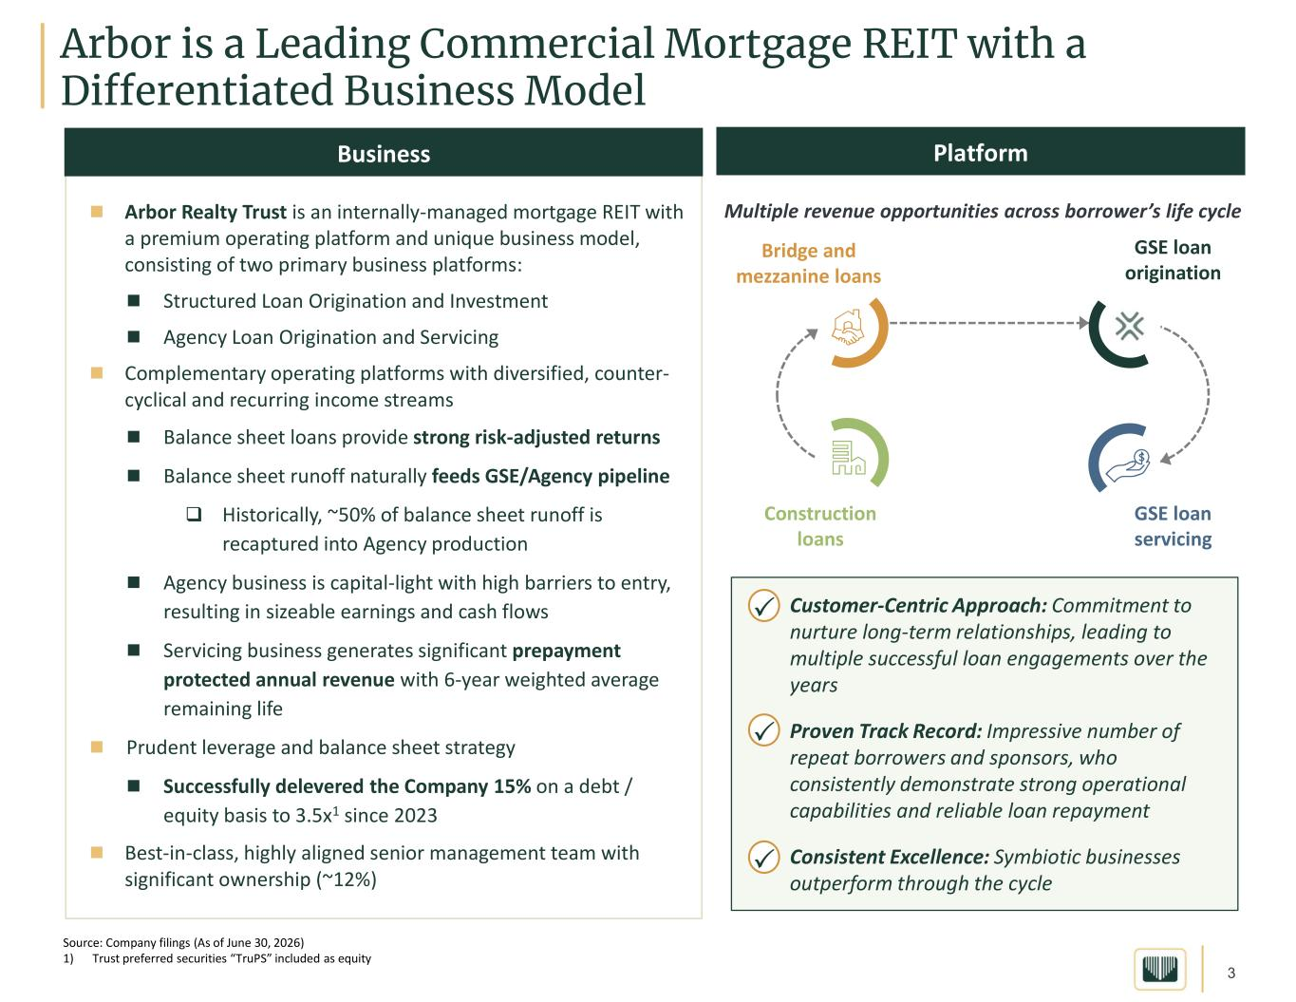
3 Arbor is a Leading Commercial Mortgage REIT with a Differentiated Business Model  Arbor Realty Trust is an internally-managed mortgage REIT with a premium operating platform and unique business model, consisting of two primary business platforms:  Structured Loan Origination and Investment  Agency Loan Origination and Servicing  Complementary operating platforms with diversified, counter- cyclical and recurring income streams  Balance sheet loans provide strong risk-adjusted returns  Balance sheet runoff naturally feeds GSE/Agency pipeline  Historically, ~50% of balance sheet runoff is recaptured into Agency production  Agency business is capital-light with high barriers to entry, resulting in sizeable earnings and cash flows  Servicing business generates significant prepayment protected annual revenue with 6-year weighted average remaining life  Prudent leverage and balance sheet strategy  Successfully delevered the Company 15% on a debt / equity basis to 3.5x1 since 2023  Best-in-class, highly aligned senior management team with significant ownership (~12%) Business Source: Company filings (As of June 30, 2026) 1) Trust preferred securities “TruPS” included as equity Platform • Customer-Centric Approach: Commitment to nurture long-term relationships, leading to multiple successful loan engagements over the years • Proven Track Record: Impressive number of repeat borrowers and sponsors, who consistently demonstrate strong operational capabilities and reliable loan repayment • Consistent Excellence: Symbiotic businesses outperform through the cycle    Bridge and mezzanine loans Construction loans GSE loan origination GSE loan servicing Multiple revenue opportunities across borrower’s life cycle

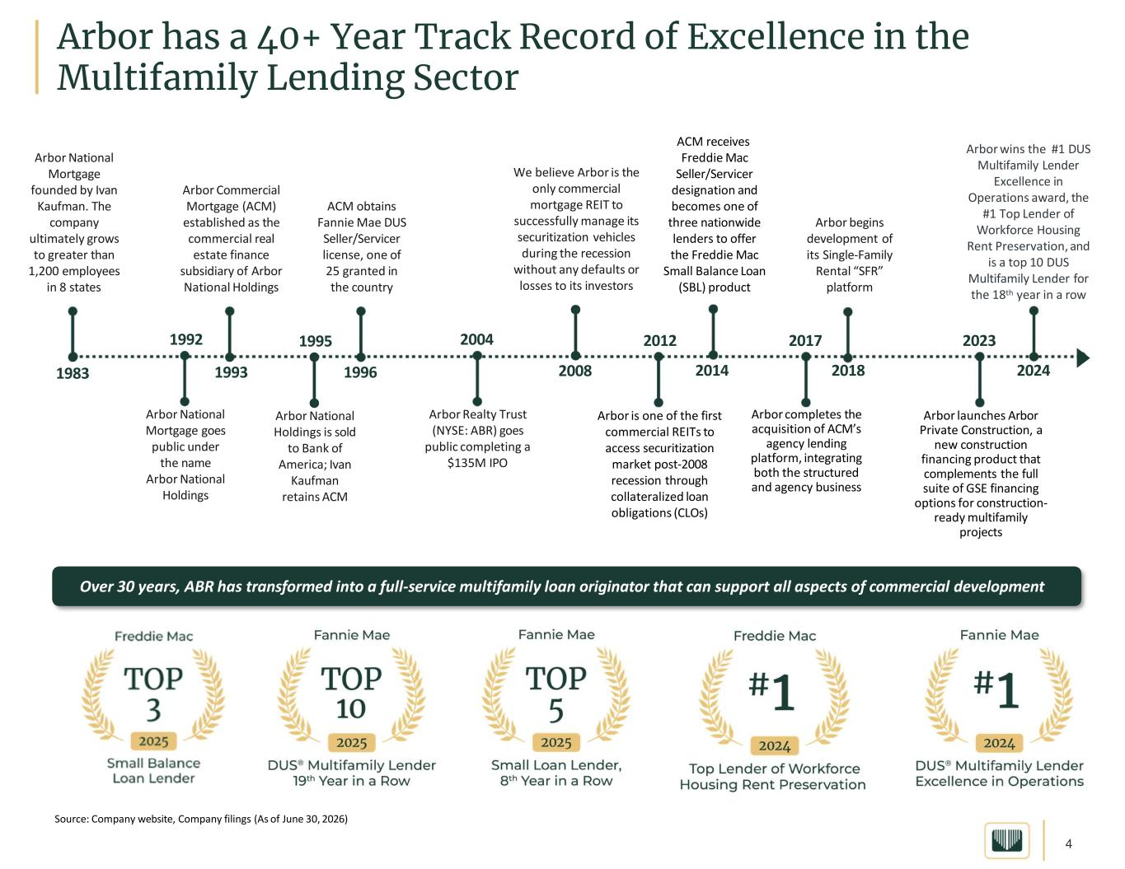
4 Arbor has a 40+ Year Track Record of Excellence in the Multifamily Lending Sector Arbor National Mortgage founded by Ivan Kaufman. The company ultimately grows to greater than 1,200 employees in 8 states 1983 1992 Arbor National Mortgage goes public under the name Arbor National Holdings Arbor Commercial Mortgage (ACM) established as the commercial real estate finance subsidiary of Arbor National Holdings 1993 Arbor Realty Trust (NYSE: ABR) goes public completing a $135M IPO 2004 ACM obtains Fannie Mae DUS Seller/Servicer license, one of 25 granted in the country 1996 Arbor is one of the first commercial REITs to access securitization market post-2008 recession through collateralized loan obligations (CLOs) 2012 ACM receives Freddie Mac Seller/Servicer designation and becomes one of three nationwide lenders to offer the Freddie Mac Small Balance Loan (SBL) product 2014 Arbor completes the acquisition of ACM’s agency lending platform, integrating both the structured and agency business 2017 Arbor begins development of its Single-Family Rental “SFR” platform 2018 Arbor wins the #1 DUS Multifamily Lender Excellence in Operations award, the #1 Top Lender of Workforce Housing Rent Preservation, and is a top 10 DUS Multifamily Lender for the 18th year in a row 2024 Arbor launches Arbor Private Construction, a new construction financing product that complements the full suite of GSE financing options for construction- ready multifamily projects 2023 Over 30 years, ABR has transformed into a full-service multifamily loan originator that can support all aspects of commercial development 1995 Arbor National Holdings is sold to Bank of America; Ivan Kaufman retains ACM We believe Arbor is the only commercial mortgage REIT to successfully manage its securitization vehicles during the recession without any defaults or losses to its investors 2008 Source: Company website, Company filings (As of June 30, 2026)

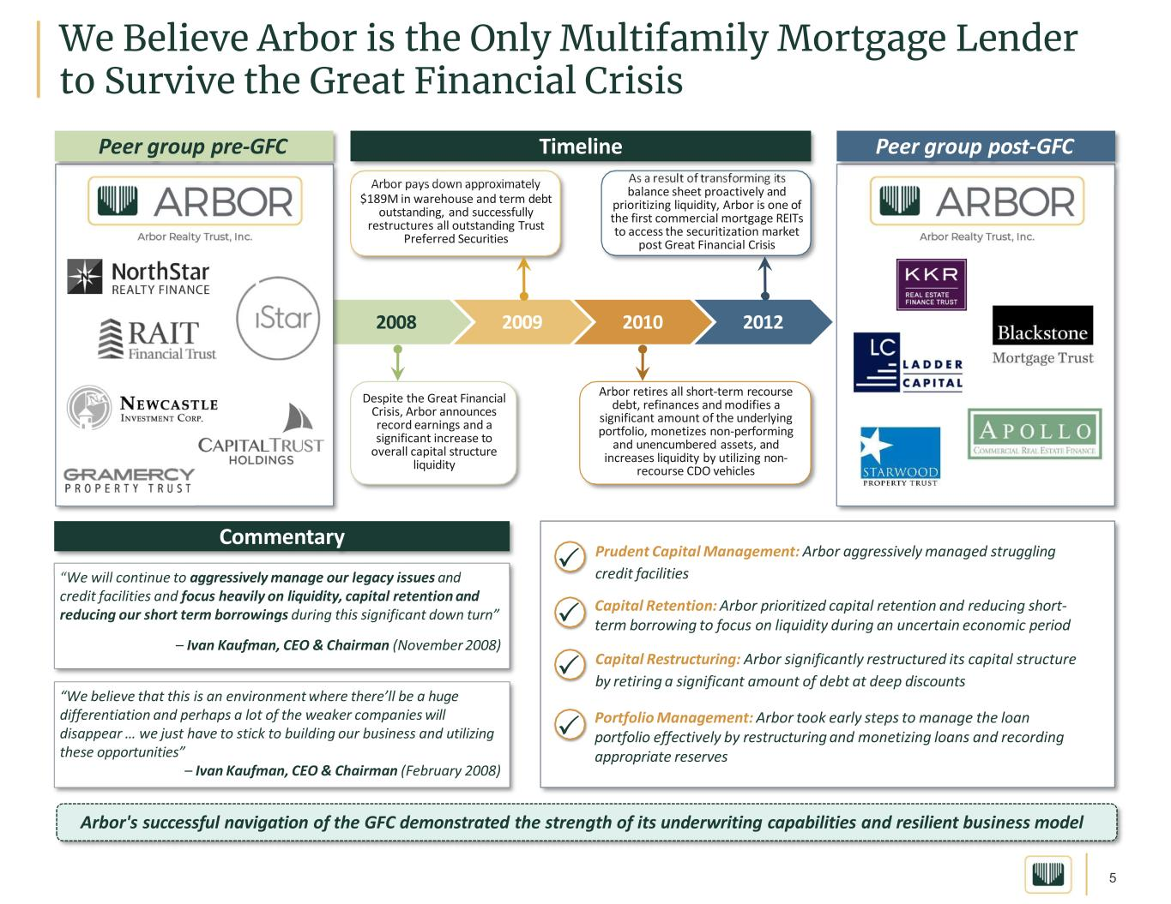
5 2008 We Believe Arbor is the Only Multifamily Mortgage Lender to Survive the Great Financial Crisis 2009 2010 2012 Despite the Great Financial Crisis, Arbor announces record earnings and a significant increase to overall capital structure liquidity Arbor pays down approximately $189M in warehouse and term debt outstanding, and successfully restructures all outstanding Trust Preferred Securities Arbor retires all short-term recourse debt, refinances and modifies a significant amount of the underlying portfolio, monetizes non-performing and unencumbered assets, and increases liquidity by utilizing non- recourse CDO vehicles As a result of transforming its balance sheet proactively and prioritizing liquidity, Arbor is one of the first commercial mortgage REITs to access the securitization market post Great Financial Crisis “We will continue to aggressively manage our legacy issues and credit facilities and focus heavily on liquidity, capital retention and reducing our short term borrowings during this significant down turn” – Ivan Kaufman, CEO & Chairman (November 2008) “We believe that this is an environment where there’ll be a huge differentiation and perhaps a lot of the weaker companies will disappear … we just have to stick to building our business and utilizing these opportunities” – Ivan Kaufman, CEO & Chairman (February 2008) Capital Retention: Arbor prioritized capital retention and reducing short- term borrowing to focus on liquidity during an uncertain economic period Portfolio Management: Arbor took early steps to manage the loan portfolio effectively by restructuring and monetizing loans and recording appropriate reserves Timeline Commentary Arbor's successful navigation of the GFC demonstrated the strength of its underwriting capabilities and resilient business model Peer group pre-GFC Peer group post-GFC  Capital Restructuring: Arbor significantly restructured its capital structure by retiring a significant amount of debt at deep discounts Prudent Capital Management: Arbor aggressively managed struggling credit facilities   

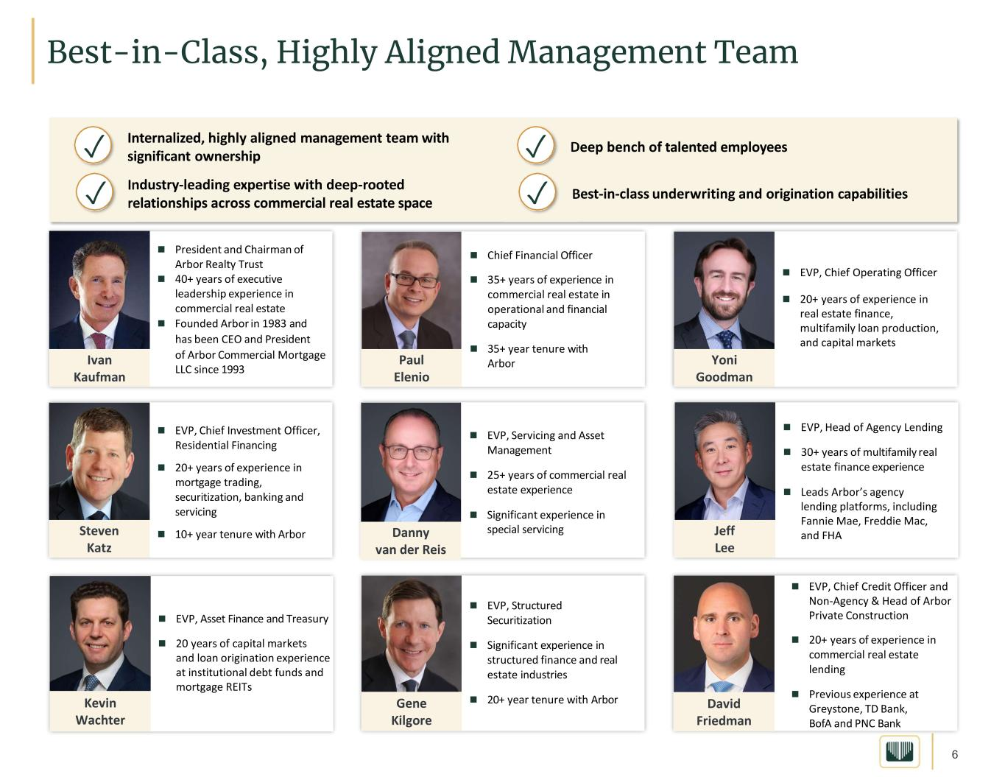
6 Internalized, highly aligned management team with significant ownership Industry-leading expertise with deep-rooted relationships across commercial real estate space Deep bench of talented employees Best-in-class underwriting and origination capabilities ✓ ✓ ✓ ✓ Best-in-Class, Highly Aligned Management Team  EVP, Chief Operating Officer  20+ years of experience in real estate finance, multifamily loan production, and capital markets  President and Chairman of Arbor Realty Trust  40+ years of executive leadership experience in commercial real estate  Founded Arbor in 1983 and has been CEO and President of Arbor Commercial Mortgage LLC since 1993  EVP, Structured Securitization  Significant experience in structured finance and real estate industries  20+ year tenure with Arbor  EVP, Head of Agency Lending  30+ years of multifamily real estate finance experience  Leads Arbor’s agency lending platforms, including Fannie Mae, Freddie Mac, and FHA  EVP, Chief Investment Officer, Residential Financing  20+ years of experience in mortgage trading, securitization, banking and servicing  10+ year tenure with Arbor  EVP, Servicing and Asset Management  25+ years of commercial real estate experience  Significant experience in special servicing  EVP, Asset Finance and Treasury  20 years of capital markets and loan origination experience at institutional debt funds and mortgage REITs Ivan Kaufman Paul Elenio Yoni Goodman Steven Katz Danny van der Reis Jeff Lee Kevin Wachter Gene Kilgore David Friedman  EVP, Chief Credit Officer and Non-Agency & Head of Arbor Private Construction  20+ years of experience in commercial real estate lending  Previous experience at Greystone, TD Bank, BofA and PNC Bank  Chief Financial Officer  35+ years of experience in commercial real estate in operational and financial capacity  35+ year tenure with Arbor

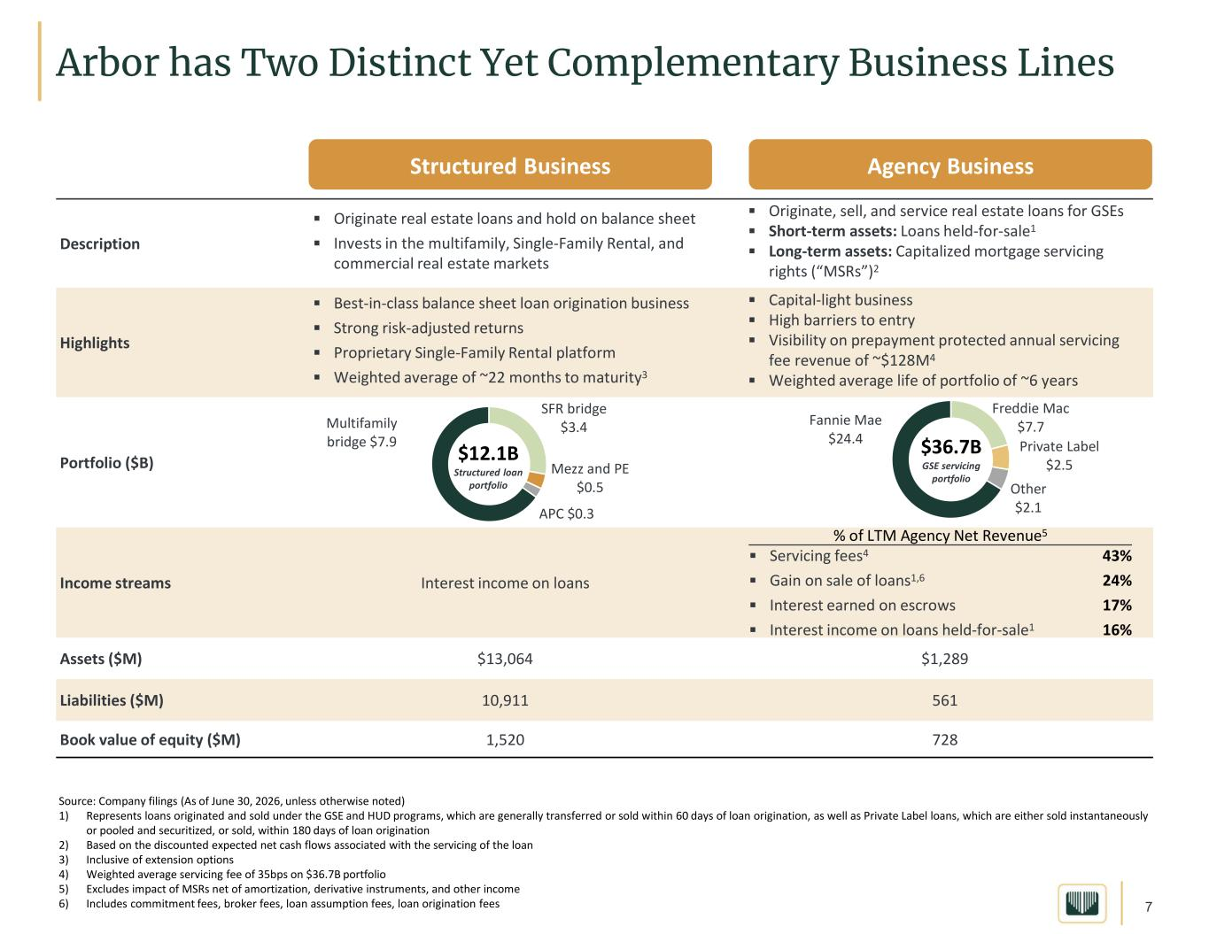
7 Arbor has Two Distinct Yet Complementary Business Lines ▪ Originate, sell, and service real estate loans for GSEs ▪ Short-term assets: Loans held-for-sale1 ▪ Long-term assets: Capitalized mortgage servicing rights (“MSRs”)2 ▪ Originate real estate loans and hold on balance sheet ▪ Invests in the multifamily, Single-Family Rental, and commercial real estate markets Description ▪ Capital-light business ▪ High barriers to entry ▪ Visibility on prepayment protected annual servicing fee revenue of ~$128M4 ▪ Weighted average life of portfolio of ~6 years ▪ Best-in-class balance sheet loan origination business ▪ Strong risk-adjusted returns ▪ Proprietary Single-Family Rental platform ▪ Weighted average of ~22 months to maturity3 Highlights Portfolio ($B) Interest income on loansIncome streams $1,289 $13,064 Assets ($M) 561 10,911 Liabilities ($M) 728 1,520Book value of equity ($M) Structured Business Agency Business Multifamily bridge $7.9 SFR bridge $3.4 Mezz and PE $0.5 APC $0.3 $12.1B Structured loan portfolio Freddie Mac $7.7 Private Label $2.5 Other $2.1 Fannie Mae $24.4 $36.7B GSE servicing portfolio Source: Company filings (As of June 30, 2026, unless otherwise noted) 1) Represents loans originated and sold under the GSE and HUD programs, which are generally transferred or sold within 60 days of loan origination, as well as Private Label loans, which are either sold instantaneously or pooled and securitized, or sold, within 180 days of loan origination 2) Based on the discounted expected net cash flows associated with the servicing of the loan 3) Inclusive of extension options 4) Weighted average servicing fee of 35bps on $36.7B portfolio 5) Excludes impact of MSRs net of amortization, derivative instruments, and other income 6) Includes commitment fees, broker fees, loan assumption fees, loan origination fees % of LTM Agency Net Revenue5 43% 24% 17% 16% ▪ Servicing fees4 ▪ Gain on sale of loans1,6 ▪ Interest earned on escrows ▪ Interest income on loans held-for-sale1

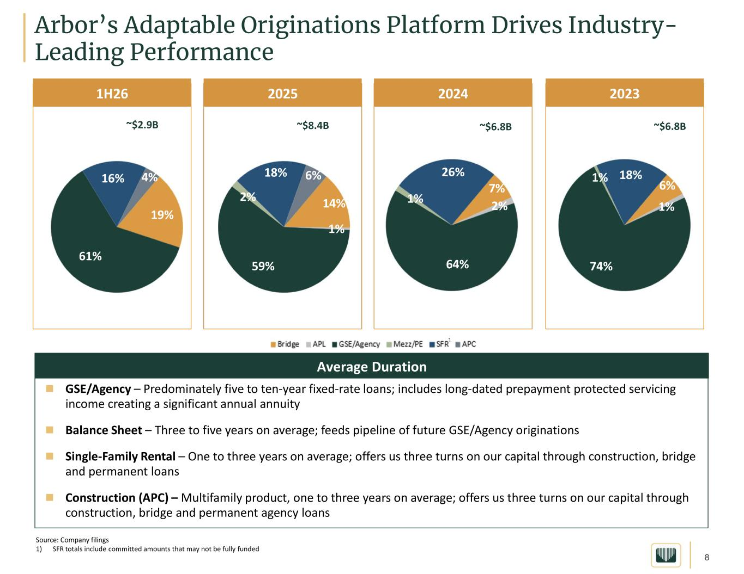
8  GSE/Agency – Predominately five to ten-year fixed-rate loans; includes long-dated prepayment protected servicing income creating a significant annual annuity  Balance Sheet – Three to five years on average; feeds pipeline of future GSE/Agency originations  Single-Family Rental – One to three years on average; offers us three turns on our capital through construction, bridge and permanent loans  Construction (APC) – Multifamily product, one to three years on average; offers us three turns on our capital through construction, bridge and permanent agency loans Arbor’s Adaptable Originations Platform Drives Industry- Leading Performance Source: Company filings 1) SFR totals include committed amounts that may not be fully funded Average Duration 1H26 ~$2.9B 2024 ~$6.8B 2023 ~$6.8B 2025 ~$8.4B 14% 1% 59% 2% 18% 6% 1 7% 2% 64% 1% 26% 6% 1% 74% 1% 18% 19% 61% 16% 4%

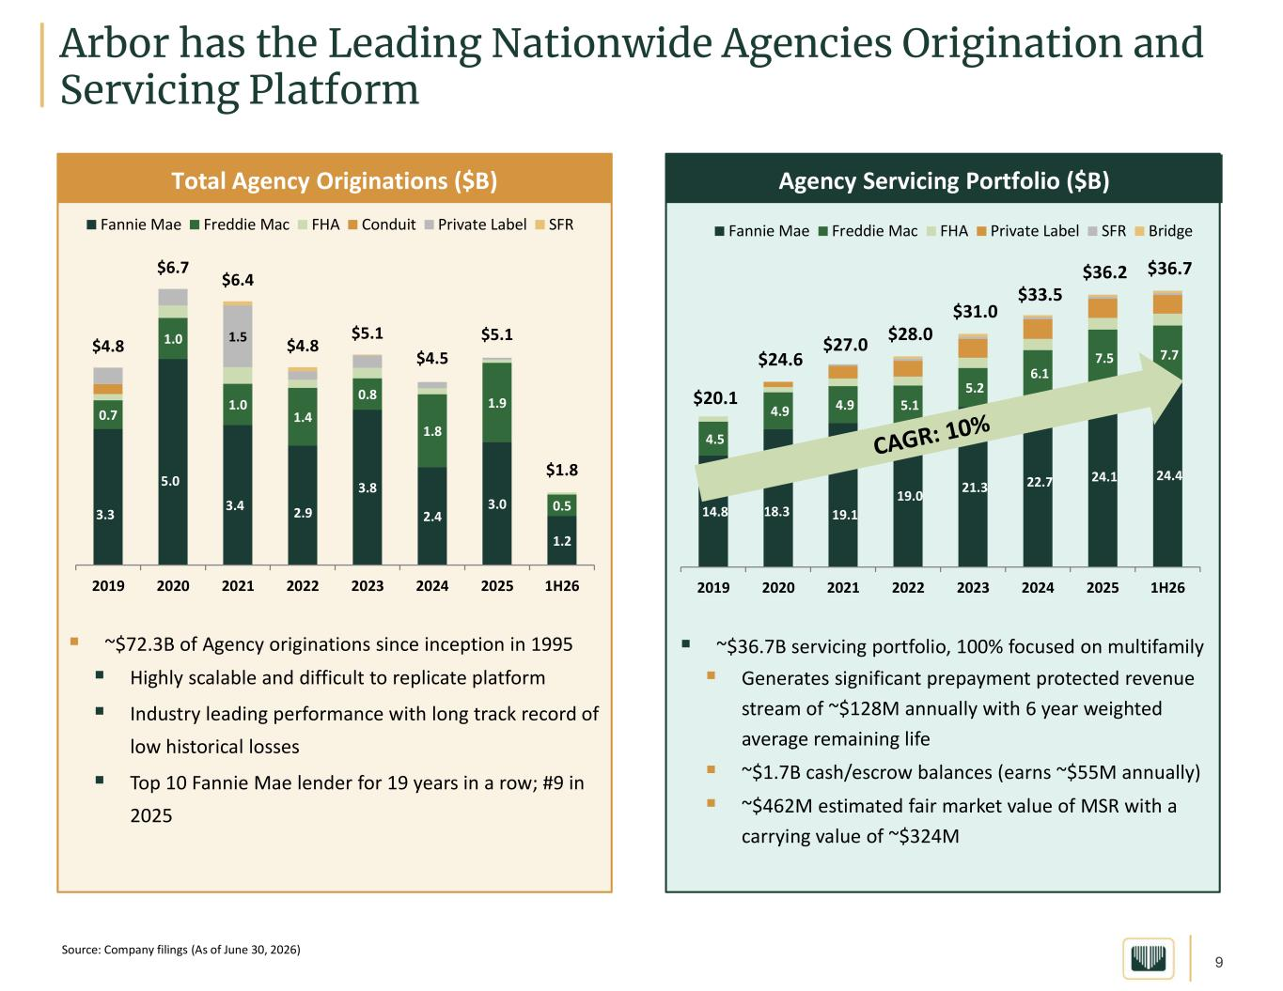
9 Agency Servicing Portfolio ($B) ▪ ~$36.7B servicing portfolio, 100% focused on multifamily ▪ Generates significant prepayment protected revenue stream of ~$128M annually with 6 year weighted average remaining life ▪ ~$1.7B cash/escrow balances (earns ~$55M annually) ▪ ~$462M estimated fair market value of MSR with a carrying value of ~$324M Arbor has the Leading Nationwide Agencies Origination and Servicing Platform Total Agency Originations ($B) Source: Company filings (As of June 30, 2026) 14.8 18.3 19.1 19.0 21.3 22.7 24.1 24.4 4.5 4.9 4.9 5.1 5.2 6.1 7.5 7.7 $20.1 $24.6 $27.0 $28.0 $31.0 $33.5 $36.2 $36.7 2019 2020 2021 2022 2023 2024 2025 1H26 Fannie Mae Freddie Mac FHA Private Label SFR Bridge ▪ ~$72.3B of Agency originations since inception in 1995 ▪ Highly scalable and difficult to replicate platform ▪ Industry leading performance with long track record of low historical losses ▪ Top 10 Fannie Mae lender for 19 years in a row; #9 in 2025 3.3 5.0 3.4 2.9 3.8 2.4 3.0 1.2 0.7 1.0 1.0 1.4 0.8 1.8 1.9 0.5 1.5 $4.8 $6.7 $6.4 $4.8 $5.1 $4.5 $5.1 $1.8 2019 2020 2021 2022 2023 2024 2025 1H26 Fannie Mae Freddie Mac FHA Conduit Private Label SFR

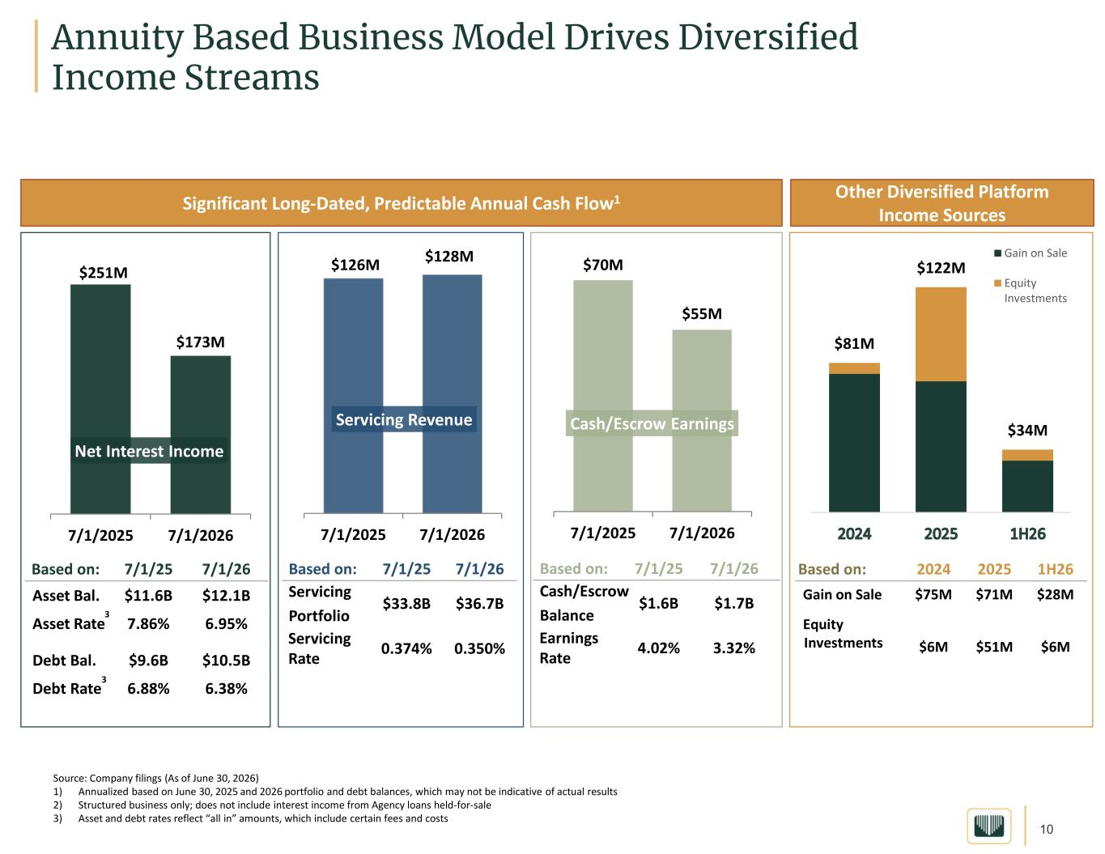
10 Annuity Based Business Model Drives Diversified Income Streams Source: Company filings (As of June 30, 2026) 1) Annualized based on June 30, 2025 and 2026 portfolio and debt balances, which may not be indicative of actual results 2) Structured business only; does not include interest income from Agency loans held-for-sale 3) Asset and debt rates reflect “all in” amounts, which include certain fees and costs 2 3 3 Significant Long-Dated, Predictable Annual Cash Flow1 Other Diversified Platform Income Sources 7/1/267/1/25Based on: $1.7B$1.6B Cash/Escrow Balance 3.32%4.02%Earnings Rate 7/1/267/1/25Based on: $36.7B$33.8B Servicing Portfolio 0.350%0.374%Servicing Rate 7/1/267/1/25Based on: $12.1B$11.6BAsset Bal. 6.95%7.86%Asset Rate $10.5B$9.6BDebt Bal. 6.38%6.88%Debt Rate 1H2620252024Based on: $28M$71M$75MGain on Sale $6M$51M$6M Equity Investments $126M $128M 7/1/2025 7/1/2026 Servicing Revenue $70M $55M 7/1/2025 7/1/2026 Cash/Escrow Earnings 2 $81M $122M $34M Gain on Sale Equity Investments $251M $173M 7/1/2025 7/1/2026 Net Interest Income

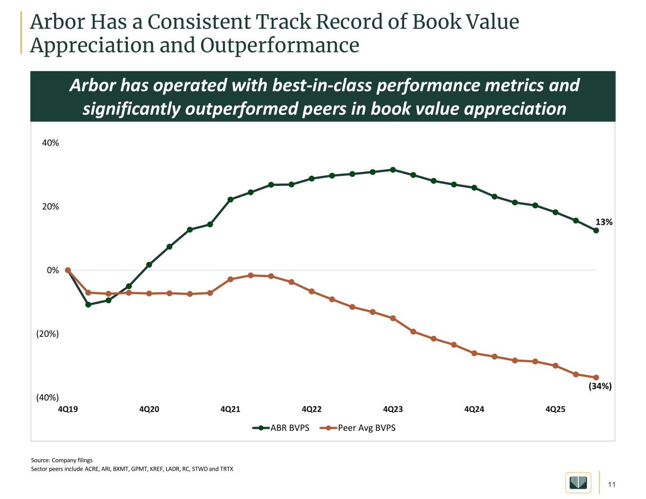
11 Arbor Has a Consistent Track Record of Book Value Appreciation and Outperformance Source: Company filings Sector peers include ACRE, ARI, BXMT, GPMT, KREF, LADR, RC, STWD and TRTX 13% (34%) (40%) (20%) 0% 20% 40% 4Q19 4Q20 4Q21 4Q22 4Q23 4Q24 4Q25 A ABR BVPS Peer Avg BVPS Arbor has operated with best-in-class performance metrics and significantly outperformed peers in book value appreciation

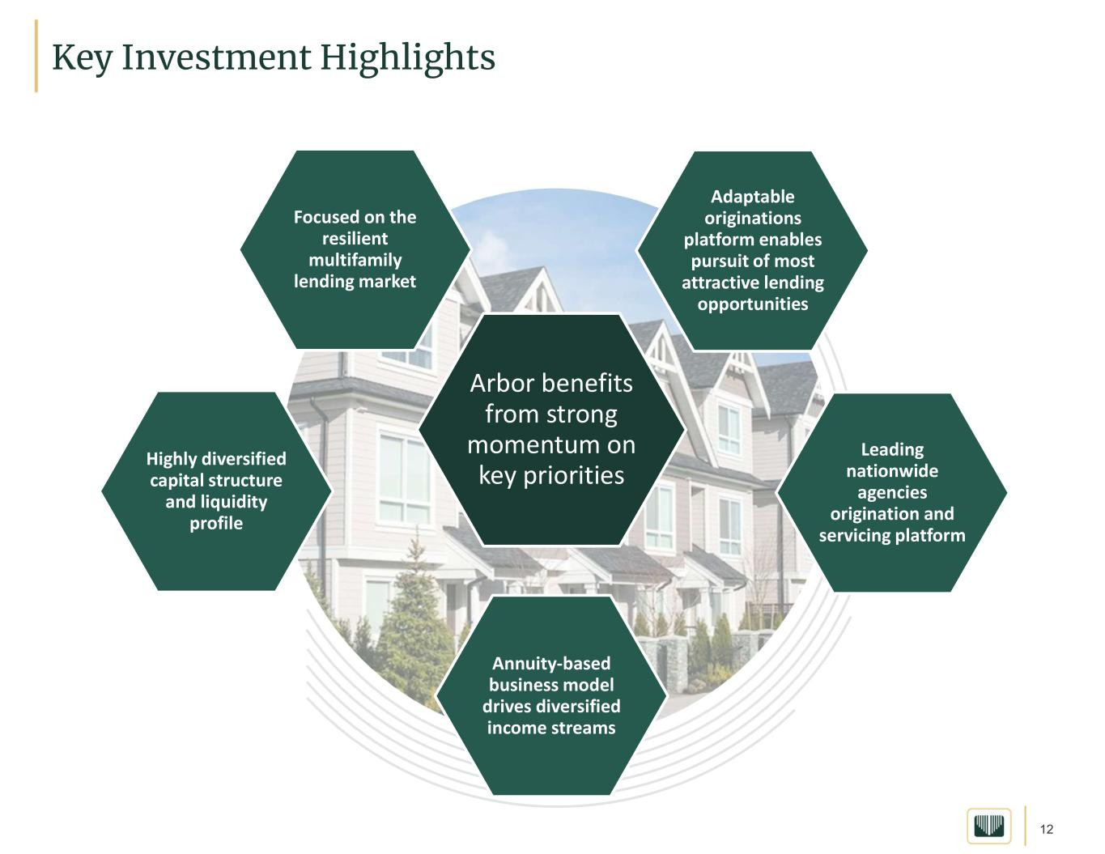
12 Key Investment Highlights Arbor benefits from strong momentum on key priorities Focused on the resilient multifamily lending market Adaptable originations platform enables pursuit of most attractive lending opportunities Leading nationwide agencies origination and servicing platform Annuity-based business model drives diversified income streams Highly diversified capital structure and liquidity profile

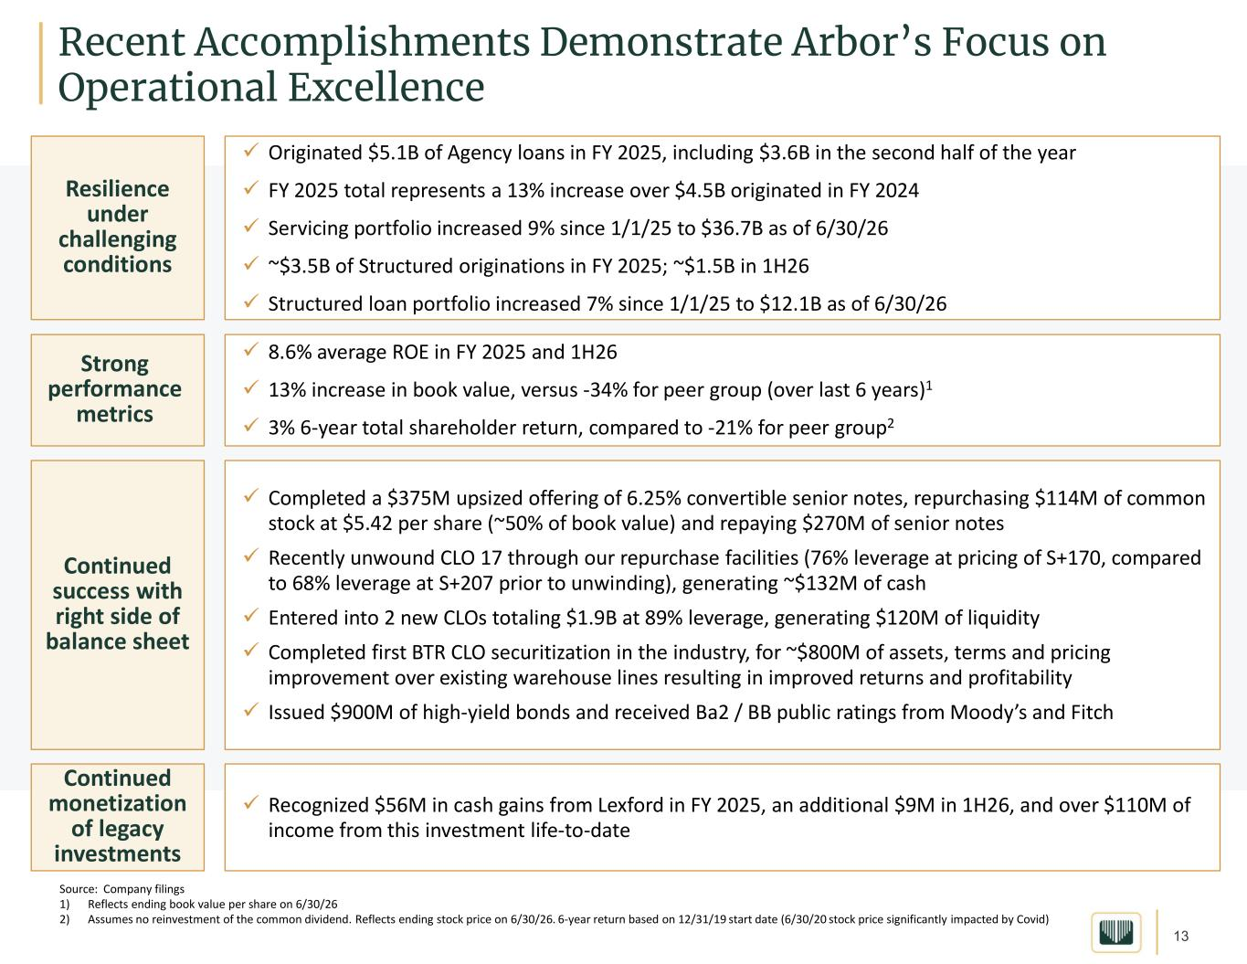
13 Recent Accomplishments Demonstrate Arbor’s Focus on Operational Excellence Continued monetization of legacy investments ✓ Recognized $56M in cash gains from Lexford in FY 2025, an additional $9M in 1H26, and over $110M of income from this investment life-to-date Continued success with right side of balance sheet ✓ Completed a $375M upsized offering of 6.25% convertible senior notes, repurchasing $114M of common stock at $5.42 per share (~50% of book value) and repaying $270M of senior notes ✓ Recently unwound CLO 17 through our repurchase facilities (76% leverage at pricing of S+170, compared to 68% leverage at S+207 prior to unwinding), generating ~$132M of cash ✓ Entered into 2 new CLOs totaling $1.9B at 89% leverage, generating $120M of liquidity ✓ Completed first BTR CLO securitization in the industry, for ~$800M of assets, terms and pricing improvement over existing warehouse lines resulting in improved returns and profitability ✓ Issued $900M of high-yield bonds and received Ba2 / BB public ratings from Moody’s and Fitch Resilience under challenging conditions ✓ Originated $5.1B of Agency loans in FY 2025, including $3.6B in the second half of the year ✓ FY 2025 total represents a 13% increase over $4.5B originated in FY 2024 ✓ Servicing portfolio increased 9% since 1/1/25 to $36.7B as of 6/30/26 ✓ ~$3.5B of Structured originations in FY 2025; ~$1.5B in 1H26 ✓ Structured loan portfolio increased 7% since 1/1/25 to $12.1B as of 6/30/26 Source: Company filings 1) Reflects ending book value per share on 6/30/26 2) Assumes no reinvestment of the common dividend. Reflects ending stock price on 6/30/26. 6-year return based on 12/31/19 start date (6/30/20 stock price significantly impacted by Covid) Strong performance metrics ✓ 8.6% average ROE in FY 2025 and 1H26 ✓ 13% increase in book value, versus -34% for peer group (over last 6 years)1 ✓ 3% 6-year total shareholder return, compared to -21% for peer group2

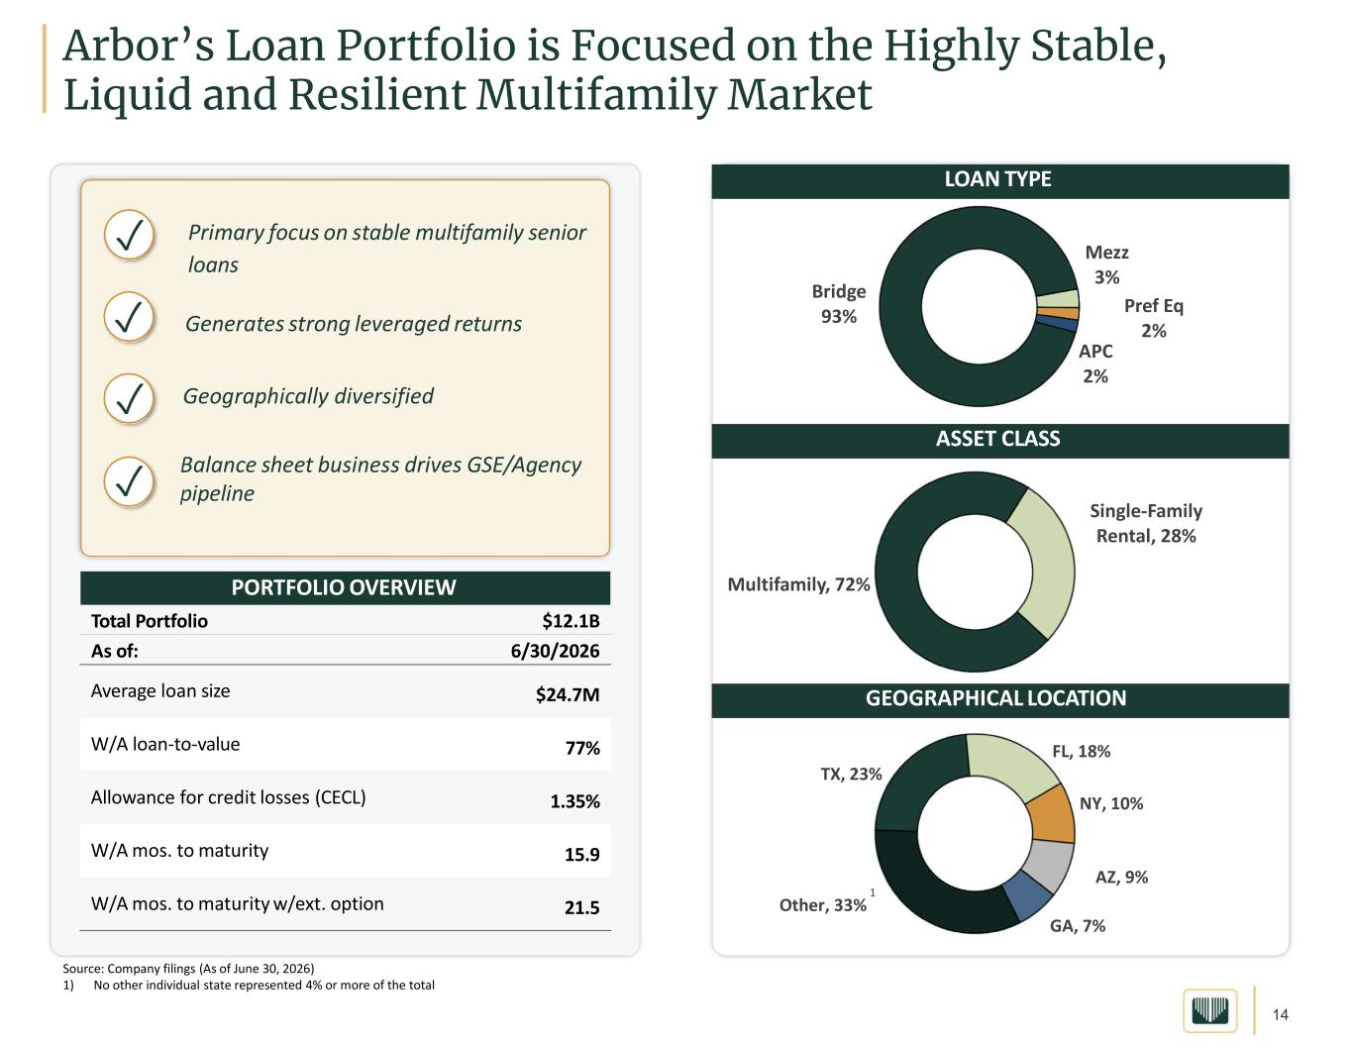
14 Source: Company filings (As of June 30, 2026) 1) No other individual state represented 4% or more of the total Arbor’s Loan Portfolio is Focused on the Highly Stable, Liquid and Resilient Multifamily Market LOAN TYPE ASSET CLASS GEOGRAPHICAL LOCATION ✓ Primary focus on stable multifamily senior loans Generates strong leveraged returns Geographically diversified Balance sheet business drives GSE/Agency pipeline ✓ ✓ ✓ PORTFOLIO OVERVIEW Bridge 93% Mezz 3% Pref Eq 2% APC 2% Multifamily, 72% Single-Family Rental, 28% TX, 23% FL, 18% NY, 10% AZ, 9% GA, 7% Other, 33% 1 $12.1BTotal Portfolio 6/30/2026As of: $24.7MAverage loan size 77%W/A loan-to-value 1.35%Allowance for credit losses (CECL) 15.9W/A mos. to maturity 21.5W/A mos. to maturity w/ext. option

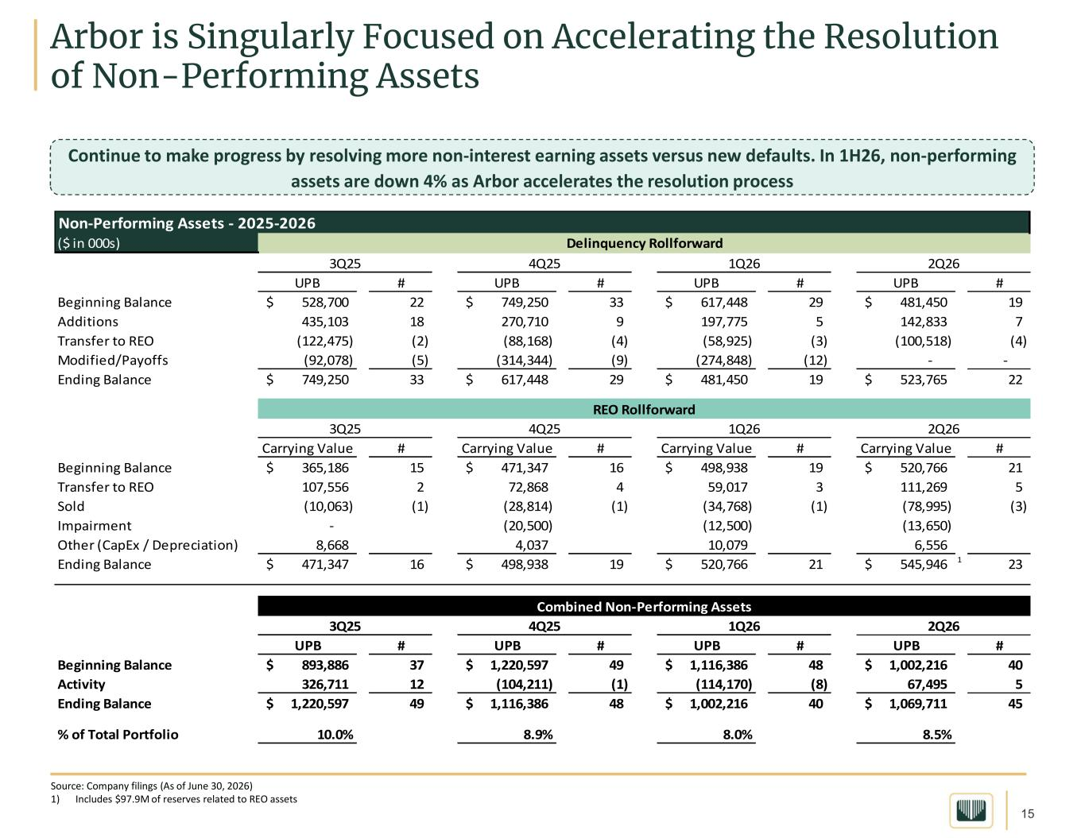
15 Arbor is Singularly Focused on Accelerating the Resolution of Non-Performing Assets Source: Company filings (As of June 30, 2026) 1) Includes $97.9M of reserves related to REO assets Non-Performing Assets - 2025-2026 ($ in 000s) UPB # UPB # UPB # UPB # Beginning Balance 528,700$ 22 749,250$ 33 617,448$ 29 481,450$ 19 Additions 435,103 18 270,710 9 197,775 5 142,833 7 Transfer to REO (122,475) (2) (88,168) (4) (58,925) (3) (100,518) (4) Modified/Payoffs (92,078) (5) (314,344) (9) (274,848) (12) - - Ending Balance 749,250$ 33 617,448$ 29 481,450$ 19 523,765$ 22 Carrying Value # Carrying Value # Carrying Value # Carrying Value # Beginning Balance 365,186$ 15 471,347$ 16 498,938$ 19 520,766$ 21 Transfer to REO 107,556 2 72,868 4 59,017 3 111,269 5 Sold (10,063) (1) (28,814) (1) (34,768) (1) (78,995) (3) Impairment - (20,500) (12,500) (13,650) Other (CapEx / Depreciation) 8,668 4,037 10,079 6,556 Ending Balance 471,347$ 16 498,938$ 19 520,766$ 21 545,946$ 1 23 UPB # UPB # UPB # UPB # Beginning Balance 893,886$ 37 1,220,597$ 49 1,116,386$ 48 1,002,216$ 40 Activity 326,711 12 (104,211) (1) (114,170) (8) 67,495 5 Ending Balance 1,220,597$ 49 1,116,386$ 48 1,002,216$ 40 1,069,711$ 45 % of Total Portfolio 10.0% 8.9% 8.0% 8.5% Delinquency Rollforward REO Rollforward Combined Non-Performing Assets 3Q25 4Q25 1Q26 4Q25 1Q26 2Q26 2Q26 4Q25 1Q26 3Q25 2Q263Q25 Continue to make progress by resolving more non-interest earning assets versus new defaults. In 1H26, non-performing assets are down 4% as Arbor accelerates the resolution process

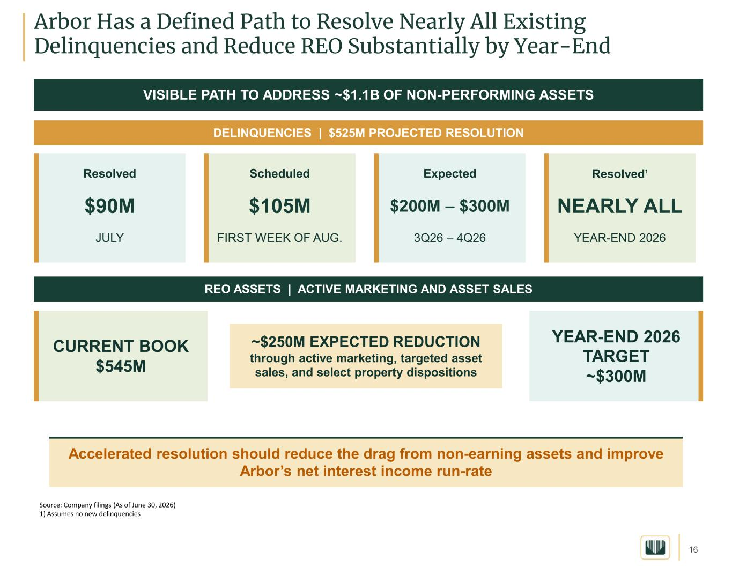
16 Arbor Has a Defined Path to Resolve Nearly All Existing Delinquencies and Reduce REO Substantially by Year-End Source: Company filings (As of June 30, 2026) 1) Assumes no new delinquencies VISIBLE PATH TO ADDRESS ~$1.1B OF NON-PERFORMING ASSETS DELINQUENCIES | $525M PROJECTED RESOLUTION Resolved $90M JULY Scheduled $105M FIRST WEEK OF AUG. Expected $200M – $300M 3Q26 – 4Q26 Resolved1 NEARLY ALL YEAR-END 2026 REO ASSETS | ACTIVE MARKETING AND ASSET SALES CURRENT BOOK $545M ~$250M EXPECTED REDUCTION through active marketing, targeted asset sales, and select property dispositions YEAR-END 2026 TARGET ~$300M Accelerated resolution should reduce the drag from non-earning assets and improve Arbor’s net interest income run-rate

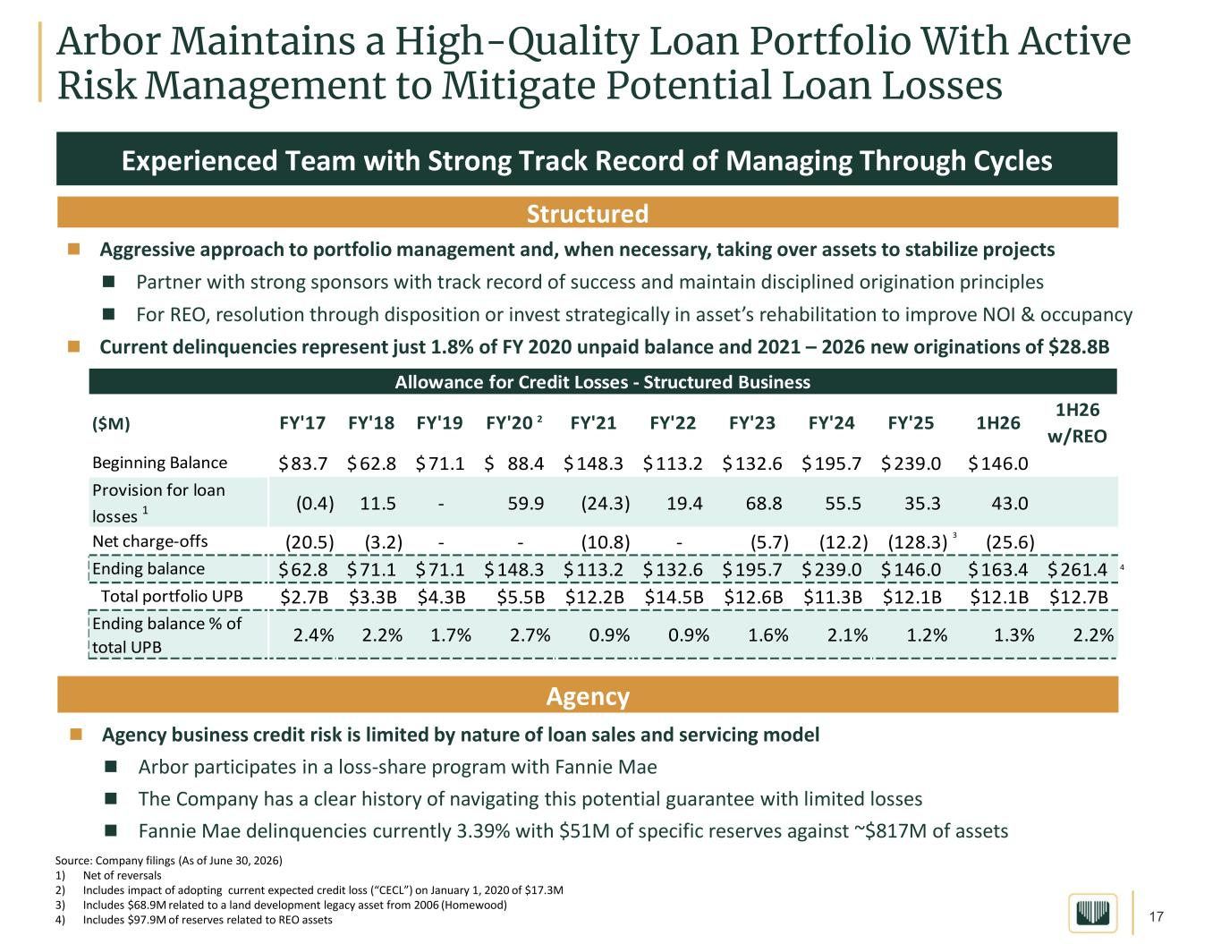
17 Arbor Maintains a High-Quality Loan Portfolio With Active Risk Management to Mitigate Potential Loan Losses Source: Company filings (As of June 30, 2026) 1) Net of reversals 2) Includes impact of adopting current expected credit loss (“CECL”) on January 1, 2020 of $17.3M 3) Includes $68.9M related to a land development legacy asset from 2006 (Homewood) 4) Includes $97.9M of reserves related to REO assets 5.7% Experienced Team with Strong Track Record of Managing Through Cycles Structured Aggressive approach to portfolio management and, when necessary, taking over assets to stabilize projects  Partner with strong sponsors with track record of success and maintain disciplined origination principles  For REO, resolution through disposition or invest strategically in asset’s rehabilitation to improve NOI & occupancy  Current delinquencies represent just 1.8% of FY 2020 unpaid balance and 2021 – 2026 new originations of $28.8B Structured Agency  Agency business credit risk is limited by nature of loan sales and servicing model  Arbor participates in a loss-share program with Fannie Mae  The Company has a clear history of navigating this potential guarantee with limited losses  Fannie Mae delinquencies currently 3.39% with $51M of specific reserves against ~$817M of assets ($M) FY'17 FY'18 FY'19 FY'20 2 FY'21 FY'22 FY'23 FY'24 FY'25 1H26 1H26 w/REO Beginning Balance 83.7$ 62.8$ 71.1$ 88.4$ 148.3$ 113.2$ 132.6$ 195.7$ 239.0$ 146.0$ Provision for loan losses 1 (0.4) 11.5 - 59.9 (24.3) 19.4 68.8 55.5 35.3 43.0 Net charge-offs (20.5) (3.2) - - (10.8) - (5.7) (12.2) (128.3) 3 (25.6) Ending balance 62.8$ 71.1$ 71.1$ 148.3$ 113.2$ 132.6$ 195.7$ 239.0$ 146.0$ 163.4$ 261.4$ 4 Total portfolio UPB $2.7B $3.3B $4.3B $5.5B $12.2B $14.5B $12.6B $11.3B $12.1B $12.1B $12.7B Ending balance % of total UPB 2.4% 2.2% 1.7% 2.7% 0.9% 0.9% 1.6% 2.1% 1.2% 1.3% 2.2% Allowance for Credit Losses - Structured Business

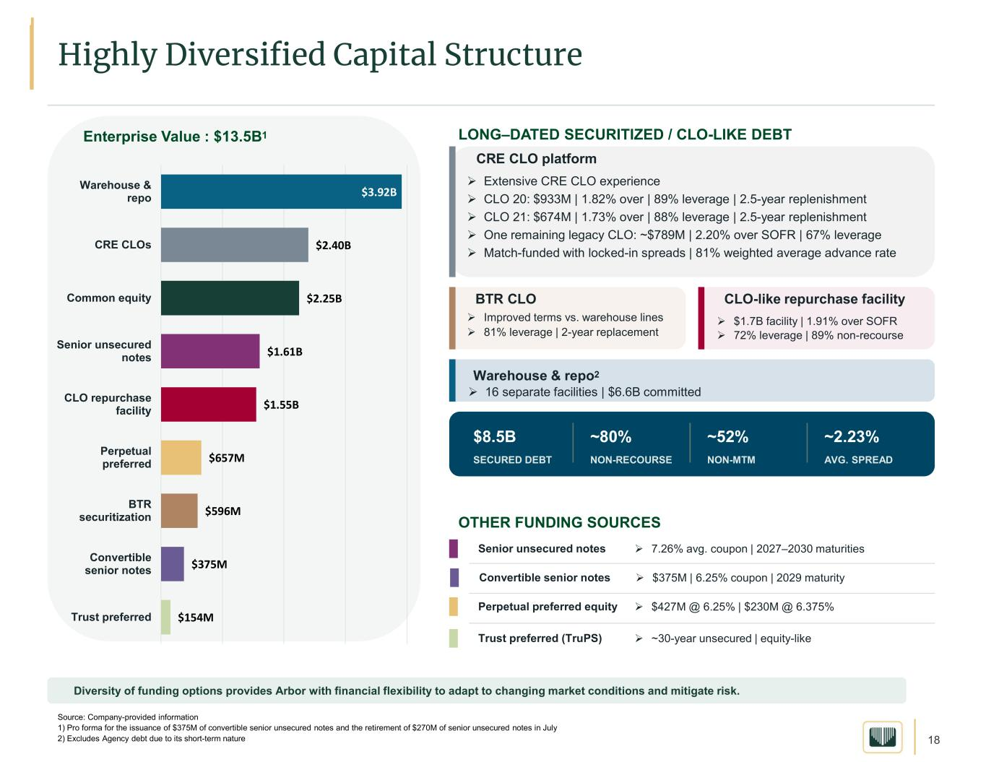
18 Enterprise Value : $13.5B1 LONG–DATED SECURITIZED / CLO-LIKE DEBT CRE CLO platform ➢ Extensive CRE CLO experience ➢ CLO 20: $933M | 1.82% over | 89% leverage | 2.5-year replenishment ➢ CLO 21: $674M | 1.73% over | 88% leverage | 2.5-year replenishment ➢ One remaining legacy CLO: ~$789M | 2.20% over SOFR | 67% leverage ➢ Match-funded with locked-in spreads | 81% weighted average advance rate BTR CLO ➢ Improved terms vs. warehouse lines ➢ 81% leverage | 2-year replacement CLO-like repurchase facility ➢ $1.7B facility | 1.91% over SOFR ➢ 72% leverage | 89% non-recourse $8.5B SECURED DEBT ~80% NON-RECOURSE ~52% NON-MTM ~2.23% AVG. SPREAD OTHER FUNDING SOURCES Warehouse & repo2 ➢ 16 separate facilities | $6.6B committed Senior unsecured notes ➢ 7.26% avg. coupon | 2027–2030 maturities Perpetual preferred equity ➢ $427M @ 6.25% | $230M @ 6.375% Trust preferred (TruPS) ➢ ~30-year unsecured | equity-like Diversity of funding options provides Arbor with financial flexibility to adapt to changing market conditions and mitigate risk. $3.92B $2.40B $2.25B $1.61B $1.55B $657M $596M $375M $154M Warehouse & repo CRE CLOs Common equity Senior unsecured notes CLO repurchase facility Perpetual preferred BTR securitization Convertible senior notes Trust preferred Source: Company-provided information 1) Pro forma for the issuance of $375M of convertible senior unsecured notes and the retirement of $270M of senior unsecured notes in July 2) Excludes Agency debt due to its short-term nature Highly Diversified Capital Structure Convertible senior notes ➢ $375M | 6.25% coupon | 2029 maturity

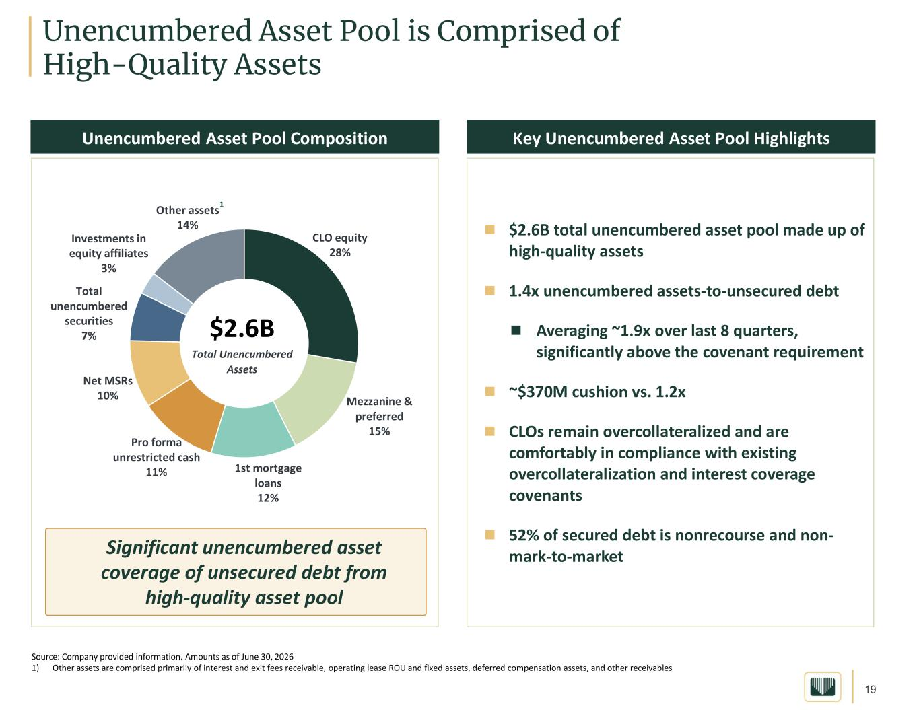
19 Unencumbered Asset Pool is Comprised of High-Quality Assets  $2.6B total unencumbered asset pool made up of high-quality assets  1.4x unencumbered assets-to-unsecured debt  Averaging ~1.9x over last 8 quarters, significantly above the covenant requirement  ~$370M cushion vs. 1.2x  CLOs remain overcollateralized and are comfortably in compliance with existing overcollateralization and interest coverage covenants  52% of secured debt is nonrecourse and non- mark-to-market CLO equity 28% Mezzanine & preferred 15% 1st mortgage loans 12% Pro forma unrestricted cash 11% Net MSRs 10% Total unencumbered securities 7% Investments in equity affiliates 3% Other assets 14% Key Unencumbered Asset Pool HighlightsUnencumbered Asset Pool Composition $2.6B Total Unencumbered Assets Significant unencumbered asset coverage of unsecured debt from high-quality asset pool Source: Company provided information. Amounts as of June 30, 2026 1) Other assets are comprised primarily of interest and exit fees receivable, operating lease ROU and fixed assets, deferred compensation assets, and other receivables 1

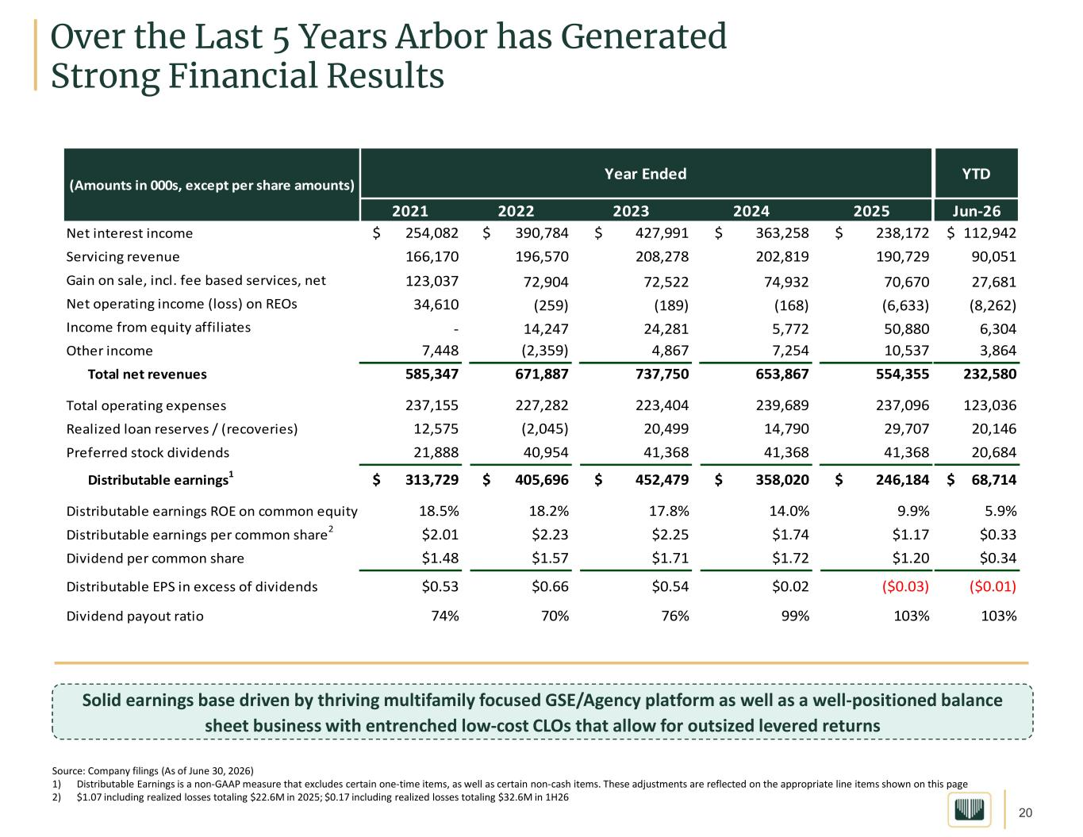
20 Over the Last 5 Years Arbor has Generated Strong Financial Results Source: Company filings (As of June 30, 2026) 1) Distributable Earnings is a non-GAAP measure that excludes certain one-time items, as well as certain non-cash items. These adjustments are reflected on the appropriate line items shown on this page 2) $1.07 including realized losses totaling $22.6M in 2025; $0.17 including realized losses totaling $32.6M in 1H26 Solid earnings base driven by thriving multifamily focused GSE/Agency platform as well as a well-positioned balance sheet business with entrenched low-cost CLOs that allow for outsized levered returns YTD Jun-26 Net interest income $ 254,082 $ 390,784 $ 427,991 $ 363,258 $ 238,172 $ 112,942 Servicing revenue 166,170 196,570 208,278 202,819 190,729 90,051 Gain on sale, incl. fee based services, net 123,037 72,904 72,522 74,932 70,670 27,681 Net operating income (loss) on REOs 34,610 (259) (189) (168) (6,633) (8,262) Income from equity affiliates - 14,247 24,281 5,772 50,880 6,304 Other income 7,448 (2,359) 4,867 7,254 10,537 3,864 Total net revenues 585,347 671,887 737,750 653,867 554,355 232,580 Total operating expenses 237,155 227,282 223,404 239,689 237,096 123,036 Realized loan reserves / (recoveries) 12,575 (2,045) 20,499 14,790 29,707 20,146 Preferred stock dividends 21,888 40,954 41,368 41,368 41,368 20,684 Distributable earnings1 $ 313,729 $ 405,696 $ 452,479 $ 358,020 $ 246,184 $ 68,714 Distributable earnings ROE on common equity 18.5% 18.2% 17.8% 14.0% 9.9% 5.9% Distributable earnings per common share2 $2.01 $2.23 $2.25 $1.74 $1.17 $0.33 Dividend per common share $1.48 $1.57 $1.71 $1.72 $1.20 $0.34 Distributable EPS in excess of dividends $0.53 $0.66 $0.54 $0.02 ($0.03) ($0.01) Dividend payout ratio 74% 70% 76% 99% 103% 103% 2025 Year Ended 20242023 (Amounts in 000s, except per share amounts) 2021 2022

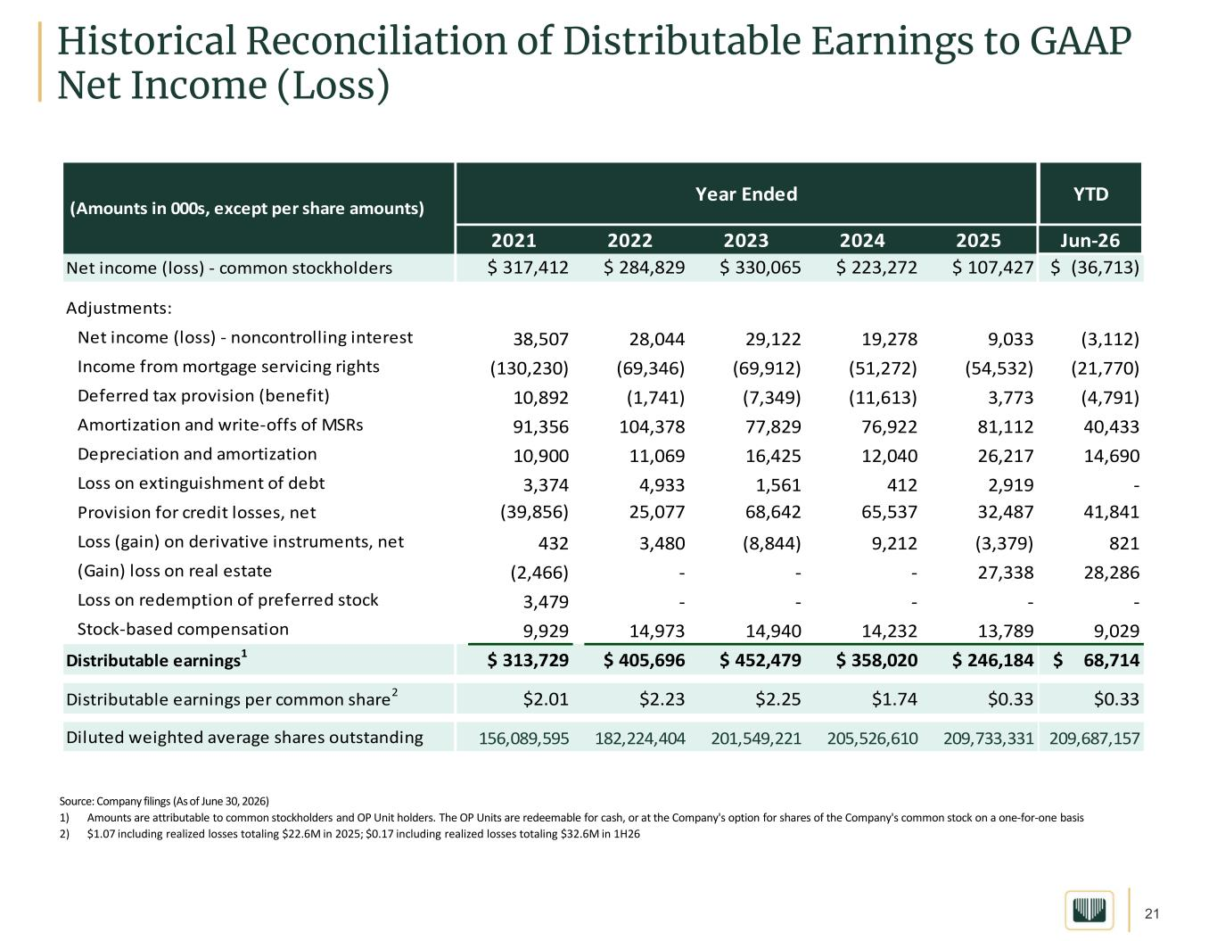
21 Historical Reconciliation of Distributable Earnings to GAAP Net Income (Loss) Source: Company filings (As of June 30, 2026) 1) Amounts are attributable to common stockholders and OP Unit holders. The OP Units are redeemable for cash, or at the Company's option for shares of the Company's common stock on a one-for-one basis 2) $1.07 including realized losses totaling $22.6M in 2025; $0.17 including realized losses totaling $32.6M in 1H26 YTD Jun-26 Net income (loss) - common stockholders $ 317,412 $ 284,829 $ 330,065 $ 223,272 $ 107,427 $ (36,713) Adjustments: Net income (loss) - noncontrolling interest 38,507 28,044 29,122 19,278 9,033 (3,112) Income from mortgage servicing rights (130,230) (69,346) (69,912) (51,272) (54,532) (21,770) Deferred tax provision (benefit) 10,892 (1,741) (7,349) (11,613) 3,773 (4,791) Amortization and write-offs of MSRs 91,356 104,378 77,829 76,922 81,112 40,433 Depreciation and amortization 10,900 11,069 16,425 12,040 26,217 14,690 Loss on extinguishment of debt 3,374 4,933 1,561 412 2,919 - Provision for credit losses, net (39,856) 25,077 68,642 65,537 32,487 41,841 Loss (gain) on derivative instruments, net 432 3,480 (8,844) 9,212 (3,379) 821 (Gain) loss on real estate (2,466) - - - 27,338 28,286 Loss on redemption of preferred stock 3,479 - - - - - Stock-based compensation 9,929 14,973 14,940 14,232 13,789 9,029 Distributable earnings1 $ 313,729 $ 405,696 $ 452,479 $ 358,020 $ 246,184 $ 68,714 Distributable earnings per common share2 $2.01 $2.23 $2.25 $1.74 $0.33 $0.33 Diluted weighted average shares outstanding 156,089,595 182,224,404 201,549,221 205,526,610 209,733,331 209,687,157 20242023 (Amounts in 000s, except per share amounts) 2021 2025 Year Ended 2022

